- Find the app you are requesting in the Volume Purchase Program site. We will use Pages as an example:
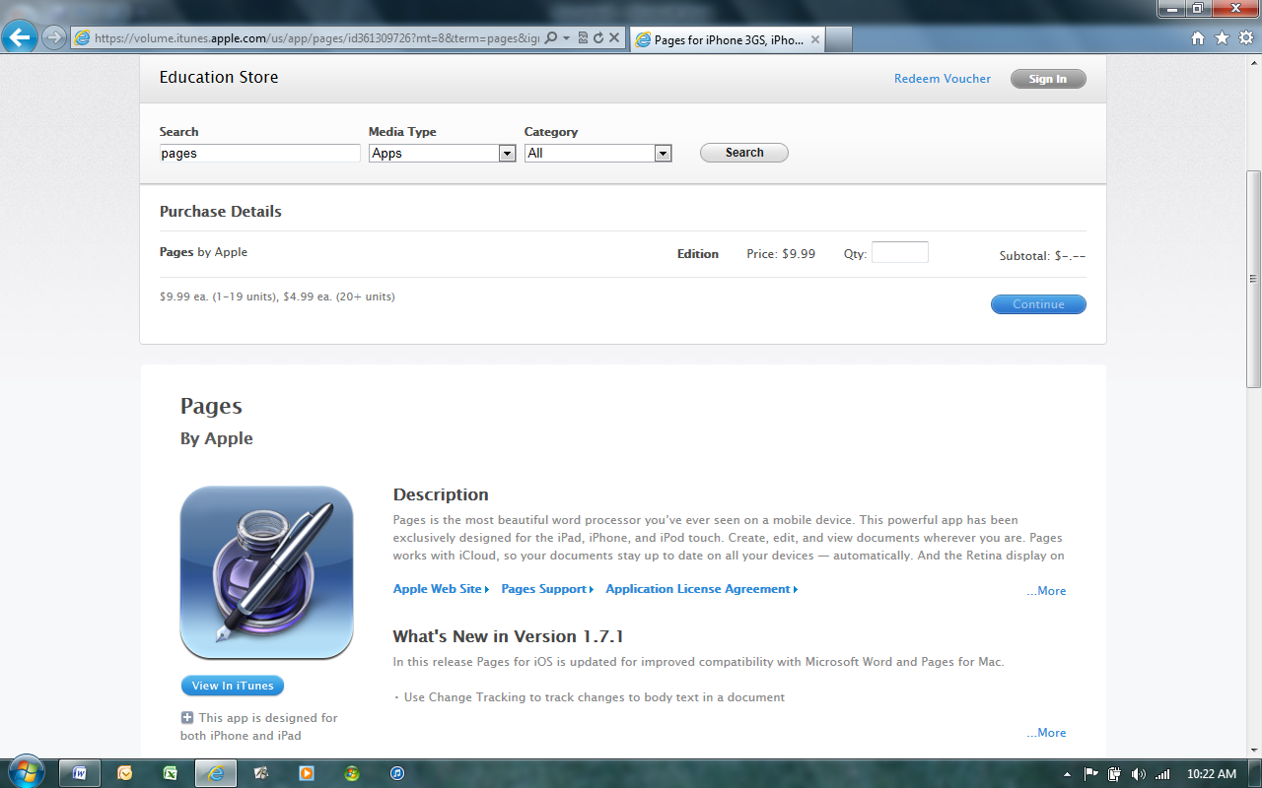

- Push the function button (fn) and the insert (prt sc) button at the same time on your keyboard:
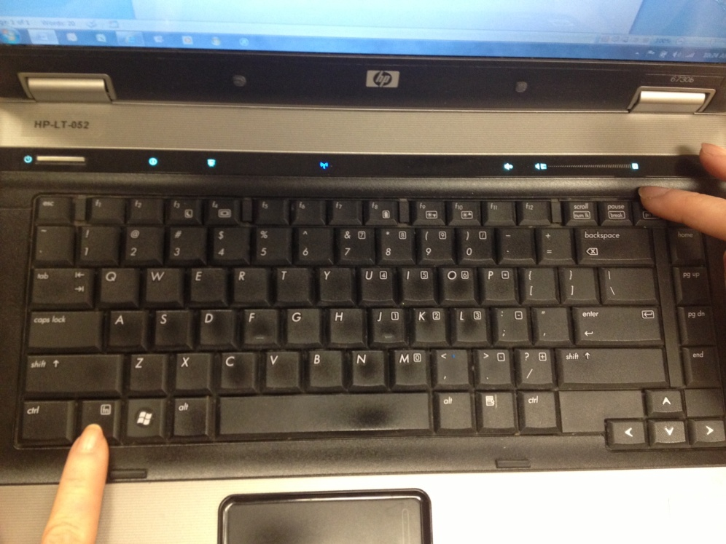

- Open the Paint program. (Found under Start, All Programs, in the Accessories folder.)
- Paste the image into the program.
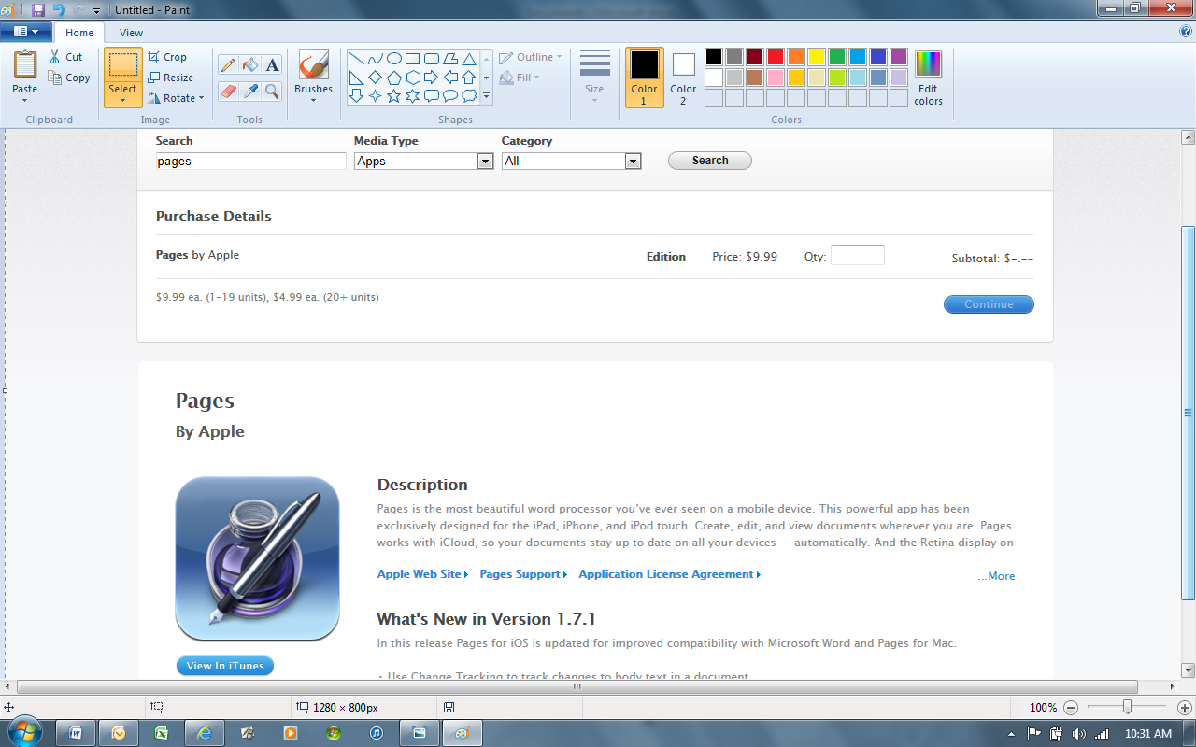
paste
crop

- Using the crop tool, make a box around the icon image by holding the left mouse button and dragging the mouse over the icon. See below for example:
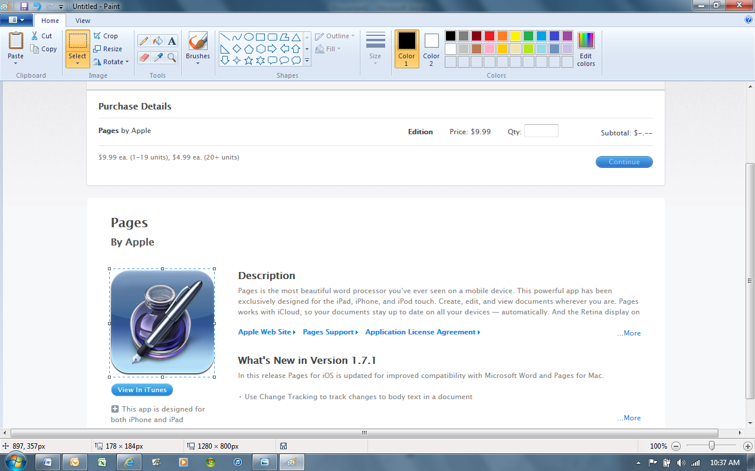
- Hit the crop button again once you are done making the box around the icon.
- Save the image to a location you are familiar with (your desktop or a folder).

- In the iPad Request form, click on the App icon image button.
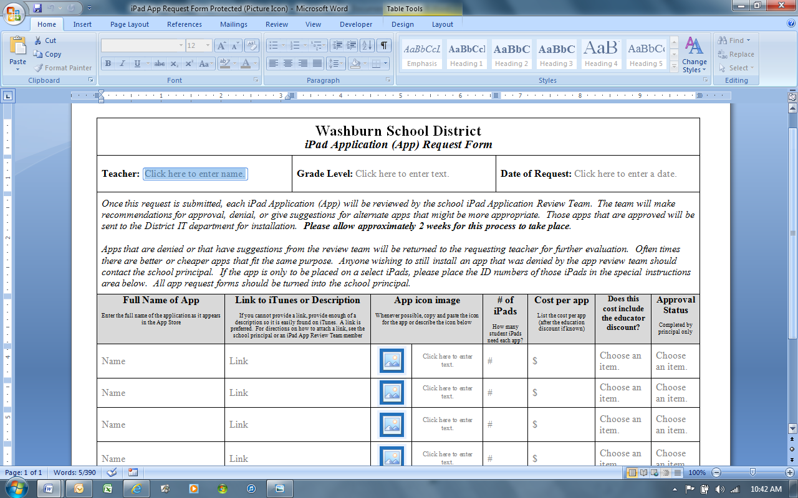

- Find your file that you saved and click insert.
- That’s it!

